Readme for Creating PDF

Run revealjs2pdf.cmd

Acrobat Reader shows this message:

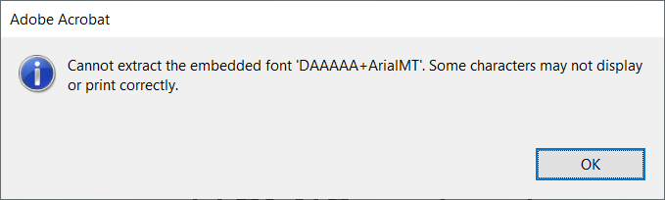

Create a second PDF with Acrobat Reader to get rid of that message:

